Realtime data from TRADETIGER, TO AMIBROKER, FCHARTS

1Preface 2

2System Requirements 2

3Setup 2

4Setup for AmiBroker Users- 3

5GETTING REAL TIME DATA FEED TO EXCEL 4

6Getting Realtime Feed to AMIBroker 6

7Realtime feed to FCharts.......... 6

8Backfill with Trade Tiger 7

9Backfill with Data Downloader 8

10Troubleshooting 9

# Preface

1. This utility was originally developed to feed real time quotes from NOW (Neat on Web) to Amibroker and distributed it freely with source code. After using it for some period, it was realised that with some further coding, it can be used to feed real time quotes from NEST, ODIN, Trade Tiger, Google and Yahoo to charting applications like Amibroker, Fcharts Qtstalker and Metastock also. This utility was upgraded to various versions. and now it has become stable.
2. The utility gives RT quotes in Ami from the time you click on- Start. It does not give RT from beginning of the day. So start RT and then open backfill. Copy data upto the time you logged in into Backfill. When backfills warns you, save database and do backfill. Your data will be current.
3. You do not have to record any excel macro.
4. Since you are reading this, it means you have downloaded the zip file containing the utility and extracted it. This help file is accompanied by following files. Use the files appropriate for your setup.
5. RTTiger.xlsm – Real time feed from Trade Tiger
6. Nest3.format – This file is used by Amibroker to import backfill data
7. RTG3.format– This file is used by Amibroker to import real time data
8. Snap.xls – Sample for Trade Tiger users

# System Requirements

1. Minimum requirement is Excel 2007 – 32 bit and Windows XP or above.
2. Tested on Windows XP and Windows 2003 x64 Server, Windows 8 , Windows 7.

# Setup

1. There are two stages involved in getting real time charts with this utility.  
     
   First - Getting the realtime feed from Trading software or Google/Yahoo to Excel.  
     
   Second - Getting the realtime feed from Excel to Charting software.
2. Files of type *.xlsm can be kept anywhere in a separate folder. However, I recommend keeping them wherever your Trading Software/application resides. Users of Trade Tiger should move them to C:\Program Files\TradeTiger
3. Files of type *.format ( Nest3.format and RTG3.format ) should be moved to 'Your\Path\to\Amibroker\format folder' since Amibroker requires them there.
4. Open Excel. Click on the Office icon on top left test
5. Click on **Excel Options- Trust Center - Trusted Locations - Add New Location** and give the path of folder where your Trading Software resides. Also give the path of folder where you kept the *.xlsm files. For example, if you have kept the excel files on 'desktop\RTNOW' folder, then include that folder in trusted loactions. This way, excel will open the .xlsm file with macros enabled. Otherwise, you will have to enable macros every time.

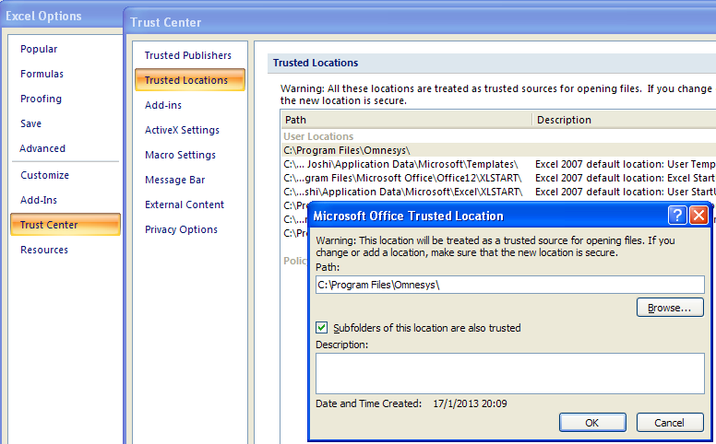

# Setup for AmiBroker Users-

1. Before trying anything in AmiBroker, create new database e.g. C:\AmiBroker\RTdata.
2. Give database folder path to create database. Thereafter, do all the settings as shown above. Those who want to combine EOD data should check against -Allow mixed EOD/Intraday data in Intraday settings.
3. **GoTO Tools Preferences-Do settings in preferences as shown below.**

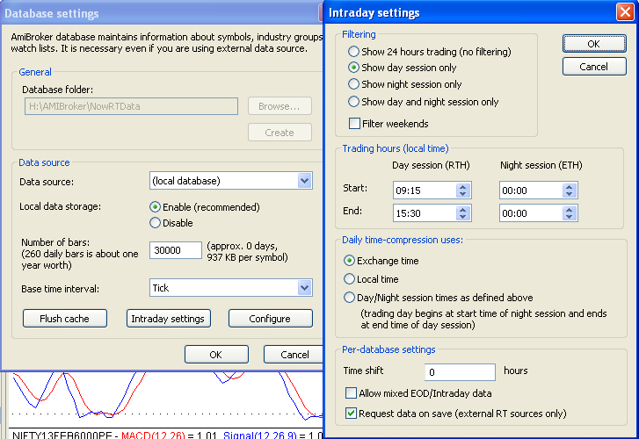

# GETTING REAL TIME DATA FEED TO EXCEL

1. **Trade Tiger has a provision "Snap to Excel" from Market watch. The necessary instructions are given on Sharekhan.com site here-**  
   <http://www.sharekhan.com/tradetigernew/Demo/SnaptoExcel/Snap_to_excel.htm>  
     
   This is similar to what is offered by ODIN. Therefore, once an excel sheet is opened through it, rest of the procedure is similar to that of ODIN as explained above. Link all the respective cells in Snap.xls to the cells in RTTiger.xlsm. Sample formulae are given there. Save the excel sheet as ‘Snap.xls’
2. **There are three stages for getting RT feed in AmiBroker from Trade Tiger.**

**1. Getting RT feed in Snap.xls from Trade Tiger.**

**2. Getting RT feed from Snap.xls to RTTiger.xlsm**

**3. Getting RT feed from RTTiger.xlsm to Ami.**

**1. Getting RT feed in Snap.xls from Trade Tiger.**

1. Login to you TradeTiger and open the desired market watch
2. Right click in the market watch and select Snap to Excel.
3. **An Excel File will open and you will see your Market Watch in it and rates changing.**
4. You have to save this Snap to Excel. Now the saved excel will show all the scripts/futures/options and you will see the rates changing. This is your source
5. Save the Snap to Excel file ( in this case the example - we save it as Snap.xls)
6. **Next time open/load the saved Snap.xls file. Do not open new sheet.**
7. Please note that you are not supposed to tinker with Excel Sheet opened through TT. You have to link cells in RTTiger.xlsm to the necessary cells/columns in that sheet by way of formula.  
   Thereafter you will get quotes in RTTiger.xlsm
8. **Most important**- put the RTTiger.xlsm or other excel files under Sharekhan\Tradetiger folder and the format files under Amibroker\format folders.]

**2. Getting RT feed from Snap.xls to RTTiger.xlsm**

1. Open Excel by clicking Start-Programs-Microsoft Office-Excel2007
2. A blank workbook opens with name book1. Ignore it and Open RTTiger.xlsm from within Excel. Change the database path to Your\AMIBROKER Database\folder\Path
3. We want **Trading Symbol, Last Trade Time, Last Traded Price, Last Traded Qty, Open interest in columns A, B, C, D, E respectively.** Therefore,
   1. **In Cell A7 type =[Snap.xls]Streaming_Stock_Watch!B9**
   2. **In Cell B7 type =TEXT(NOW(),"HH:mm:ss")**
   3. **In Cell C7 type =[Snap.xls]Streaming_Stock_Watch!E9**
   4. **In Cell D7 type =[Snap.xls]Streaming_Stock_Watch!D9**
   5. **In Cell E7 type =[Snap.xls]Streaming_Stock_Watch!V9**
4. (actual cell content of Snap.xls will vary as how u save it - but most of the case its same. and if u don’t put Open Interest in your market watch, then cell E7 in RTTiger.xlm will be skipped) do not interfere with its working.
5. In the excel sheet RTTiger, in the database path of Amibroker , use the following Amibroker Databae Path = C:\Program Files (X86)\Amibroker\RTDATA. If ur program files does not contains the (x86) part u can safely omit that part, in that case it will be Amibroker Databae Path = C:\Program Files \Amibroker\RTDATA. Here "RTDATA" is for example, you can use any other meaningful name
6. Copy the entire row in four rows below. Check the format of the columns once. Column B should have Time format and columns C, D, E should have number format.
7. **If you see the rates changing, you are done.**
8. When all done, 1st open the Snap.xls (every time open new snap to excel file or otherwise it will not work) and then open RTTiger.xlm in the Sharekhan\Tradetiger folder. RTTiger.xlm will be linked with Snap.xls and RTTiger.xlm will be active, that is it will show the live rate taken from Sharekhan Trade Tiger.)
9. Please do it yourself before asking for help as this will help you to rectify any problem you may face when something goes wrong. If you feel that the installation is corrupt, then delete all the respective files and reinstall and follow the procedure. This will help you to get streaming quotes from TradeTiger to Amibroker via RTTiger excel files

**3. Getting RT feed from RTTiger.xlsm to AmiBroker.**

1. Change the database path in Cell B1 to Your\AMIBROKER Database\folder\Path
2. **If you installed RAM disk, then give Drive Letter in Cell B2 other wise leave it blank.**
3. **Click on “Start RT Data”.**
4. **AmiBroker Should open automatically and you will see live charts moving**
5. Once you start getting data feed in AMIBroker, save the Snap.xls in TradeTiger folder. Next time, open/load the same Snap.xls file. Otherwise you will not get realtime feed.

# Getting Realtime Feed to AMIBroker

1. Once you start getting realtime quotes in Excel, next step is to get them in AmiBroker and see the charts moving. Your source can be any of NOW, Odin. Trade Tiger, Yahoo or Google. Method of feeding data to AmiBroker is similar. Here is a snapshot of RTNOW.xlsm.
2. **If you installed RAM drive, then give Drive Letter in Cell B2 other wise leave it blank . If you are not sure what is RAM Drive, keep this field blank**
3. **Give Your\Database\Path in cell B1.**
4. **Click on “Start RT Data”.**
5. **AmiBroker Should open automatically and you will see live charts moving**

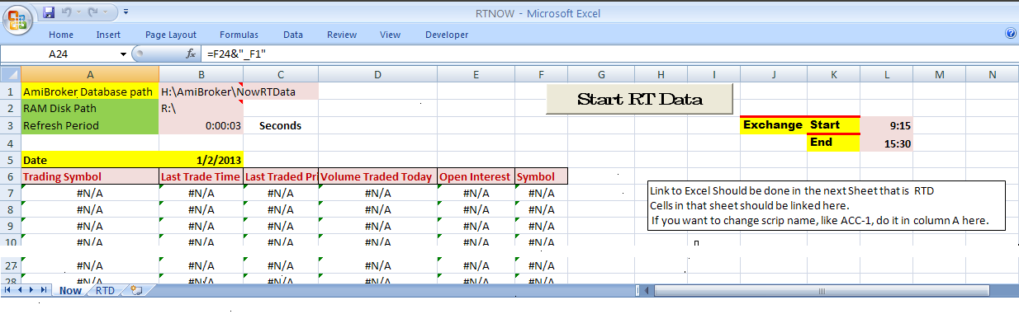

# Realtime feed to FCharts..........

1. FCharts is another application for stock charting. There are two versions of this application. 1. FChartSE is free for all users and 2. FChartPRO is paid versions. I had used the free version about two years ago. I found some discrepancies in weekly charts. That is why and also because I had money to spend, I bought AmiBroker. I installed the latest free version about a month ago. It seems to have improved a lot and added some excellent facilities in two years. New Traders are advised to use this application. FchartSE is very easy for intraday charts.
2. All the files of type *.xlsm work out of the box with FCHARTSE the free charting software.
3. Those who are not getting Last Traded time in data feed(diet ODIN) will have to click on "Start RT Data" to get current time. All others just have to start data feed application like NOW or NEST and get realtime feed to FChartSE.
4. Open NOW or Nest or which ever software
5. Open RTNOW/RTNest/RTGoogle/RTYahoo/RTODIN/RTTiger.xlsm whichever you want and check whether rates are changing. (Trust Centre settings to be done as given earlier in this thread)
6. We will have to add Date Column since it needs that. Do not add any column. Use the "Symbol" column instead. Erase its contents and type "=Today()" without quotes against each scrip in that column.
7. Open FChartSE
8. Click on Intraday and select Excel as source.
9. Click on Refil List and It will show the name of excel file.
10. Column settings as given in the image. They are self explanatory.
11. 1st Data Row in our case is 7.
12. **Click on “Start“. You can see one minute bars getting updated live in FCharts.**

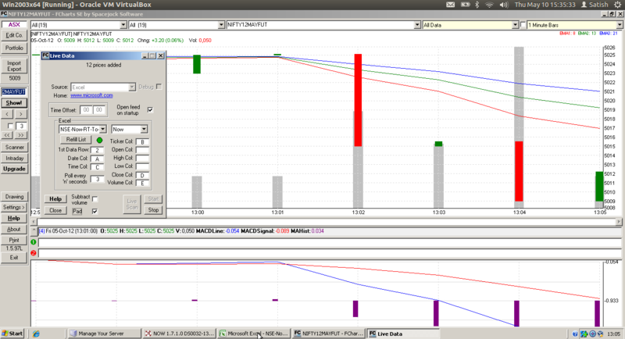

# Backfill with Trade Tiger

1. Double Click on scrip name of your choice in market watch (say SBIN) that is streamed.
2. SBIN chart opens.
3. On the SBIN chart bottom right you will find 2 little boxes > click on the one below (with Z symbol) this will open a pop-up. In pop-up click on ‘0’ & then on custom. Change the date to max or your choice & then click on plot. A tick chart has now been plotted.
4. Now on the SBIN chart - Right Click > Show > Data Listing. This will open a Data Window showing the tick data. Save this Scrip as CSV with file name SBIN to a location of your choice.
5. Import data from SBIN.csv file into AmiBroker using Import Wizard. In the last step of wizard, it will ask you whether you want to save this format for future as “Custom format’. Save the format as “TTformat”. AmiBroker will import the data into SBIN using file name SBIN.csv. You can use import ASCII for rest of the scrips using TTformat. It is that easy.
6. Sharekhan gives data in - Date, Time, volume, Open, high, low, close, average format.
7. Actually the trick lies there, save the file in the ticker name (as it appears in Ami), delete the average part via macro or while importing, keep the average as skip. Then import via ASCII is easier as the data is imported in respective ticker files in Amibroker database
8. .

# Backfill with Data Downloader

1. Data Downloader is created by Joydeep Mitra and it is hosted on Volumedigger.com.
2. A video is hosted on You tube for backfill. Link is here- <http://youtu.be/A65Si2KpK_s>
3. Apart from the video, do following settings in Data Downloader

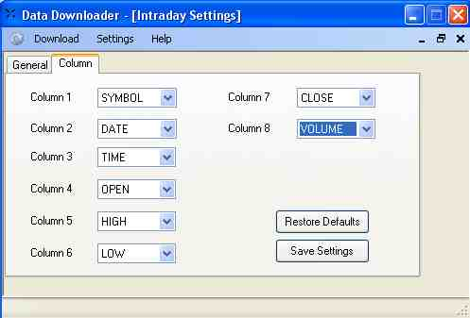

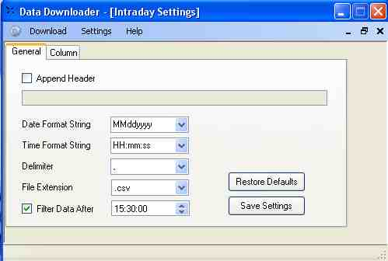

1. You can link Nest sheet the symbol will be RELIANCE-EQ, use following formula :

=IF(RIGHT(RTD!A13,3)="FUT",RTD!F13&"_F1",IF(RIGHT( RTD!A13,3)="-EQ",RTD!F13&"",RTD!A13))

1. and now the symbol will exact match of NSE symbol i.e. RELIANCE,
2. after that using © Joydeep Mitra DataDownloader,

format the intraday download as per nest column along with date i.e. dd/MM/yyyy ,

1. Edit google intraday.txt. Add the scrips (symbol should be exact as per NSE along with .NSE i.e. RELIANCE.NSE) ,
2. Download intraday data from ->INTRADAY->GOOGLE ,
3. Import all txt files in amibroker using import wizard. Save the format as “Google Intraday”.
4. BINGO all scrips backfill done in seconds.
5. Next time use “Google Intraday” format and import ASCII.

# Troubleshooting

1. I am not too good in computer related stuff, please help me.

You need not be good in computers to follow this. Follow all the instructions. If you do not understand any instruction, ask me. Sorry, I cannot do spoon feeding. Please help yourself first and thereafter I will help you.

1. I did everything as per instructions but I am not getting charts. Please help.

What do you mean by that. I cannot help you with one line information. Check whether you followed all the steps as given. Give me the exact step where you are not getting desired results and ask specific question.

1. Backfill is not happening.

What do you mean by that. I cannot help you like that. Check whether you followed all the steps as given and ask specific question. You do database setting only once. Be sure that you give same database path to RT utility and Backfill utility.